Reliable Sources
How do you tell if a source is reliable? How do you know if it is ok to use? Check your source for the following things!
Check for: Site 1 Site2
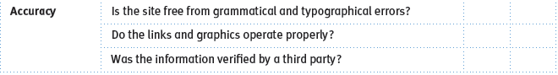
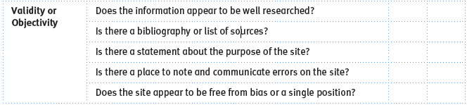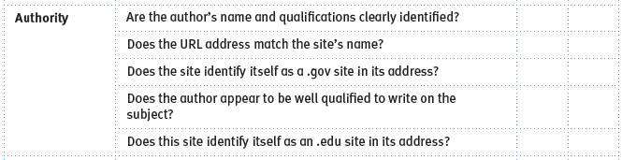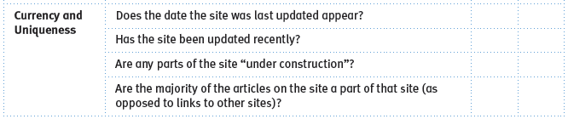
What is a reliable source? _____________________________________________________________________________
__________________________________________________________________________________________________
Where can I find reliable sources? ______________________________________________________________________ __________________________________________________________________________________________________
Why is it important to have reliable sources? _____________________________________________________________ ____________________________________________________________________________________________________________________________________________________________________________________________________

In-text Citation
I need to use an in-text citation when: _________________________________________________________ ____________________________________________________________________________________________________________________________________________________________________________________
For example, in my project or paper, I might give a quote like this:
The orange is a fruit characterized by its orange color, round shape, “rich citric acid and vitamin content,” and its many varieties (Orange, in Botany).
Or this:
“Healthy adults should eat between 20 to 35 grams of dietary fiber each day” and oranges contain soluble fiber; which could lower risk of heart disease if combined with a low-fat diet (Baggarly).
Or this:
In a study by the United States Department of Agriculture (USDA), oranges only cost an average of $0.74 per pound for the consumer and, as such, are much cheaper than a large variety of other fruits (Reed et al. 11-23).
Given this bibliography, how would you cite the following information?
The orange is the fruit from the orange tree which belongs to the Rutaceae tree family ( ).
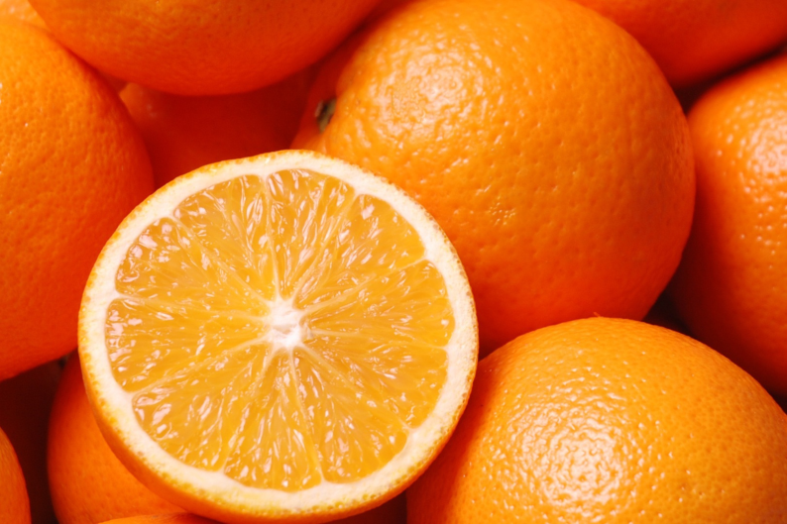 Figure 1: Photograph of oranges and a halved orange.

Table 1: Estimated costs and profits of running an orange orchard (per acre) in the San Joaquin Valley, California, USA for the first 5 years.
Bibliography
Baggarly, Jan. "Filling up on fiber." Macon Telegraph, The (GA) 27 Feb. 2012,: NewsBank. Web. 28 Feb. 2012.
O'Connell, Neil V., Craig E. Kallsen, Karen M. Klonsky, and Richard L. De Moura. "Sample Costs to Establish and
Orange Orchard and Produce Oranges." UC Davis Cost Studies. University of California Cooperative Extension,
n.d. Web. 28 Feb. 2012. <coststudies.ucdavis.edu/files/orangevs2009.pdf>.
"Orange, In Botany." Columbia Electronic Encyclopedia, 6Th Edition (2011): 1. Literary Reference Center. Web. 28 Feb.
2012.
Reed, Jane, Elizabeth Frazão, and Rachel Itskowitz. "How Much Do Americans Pay for Fruits and Vegetables?."
Economic Research Service. United States Department of Agriculture, n.d. Web. 28 Feb.2012. <http://www.ers.usda.gov/publications/aib790/aib790.pdf>.
sunnyUK. 1506 Orange. 2008. Fotopedia, Online. Fotopedia. Web. 28 Feb. 2012.

