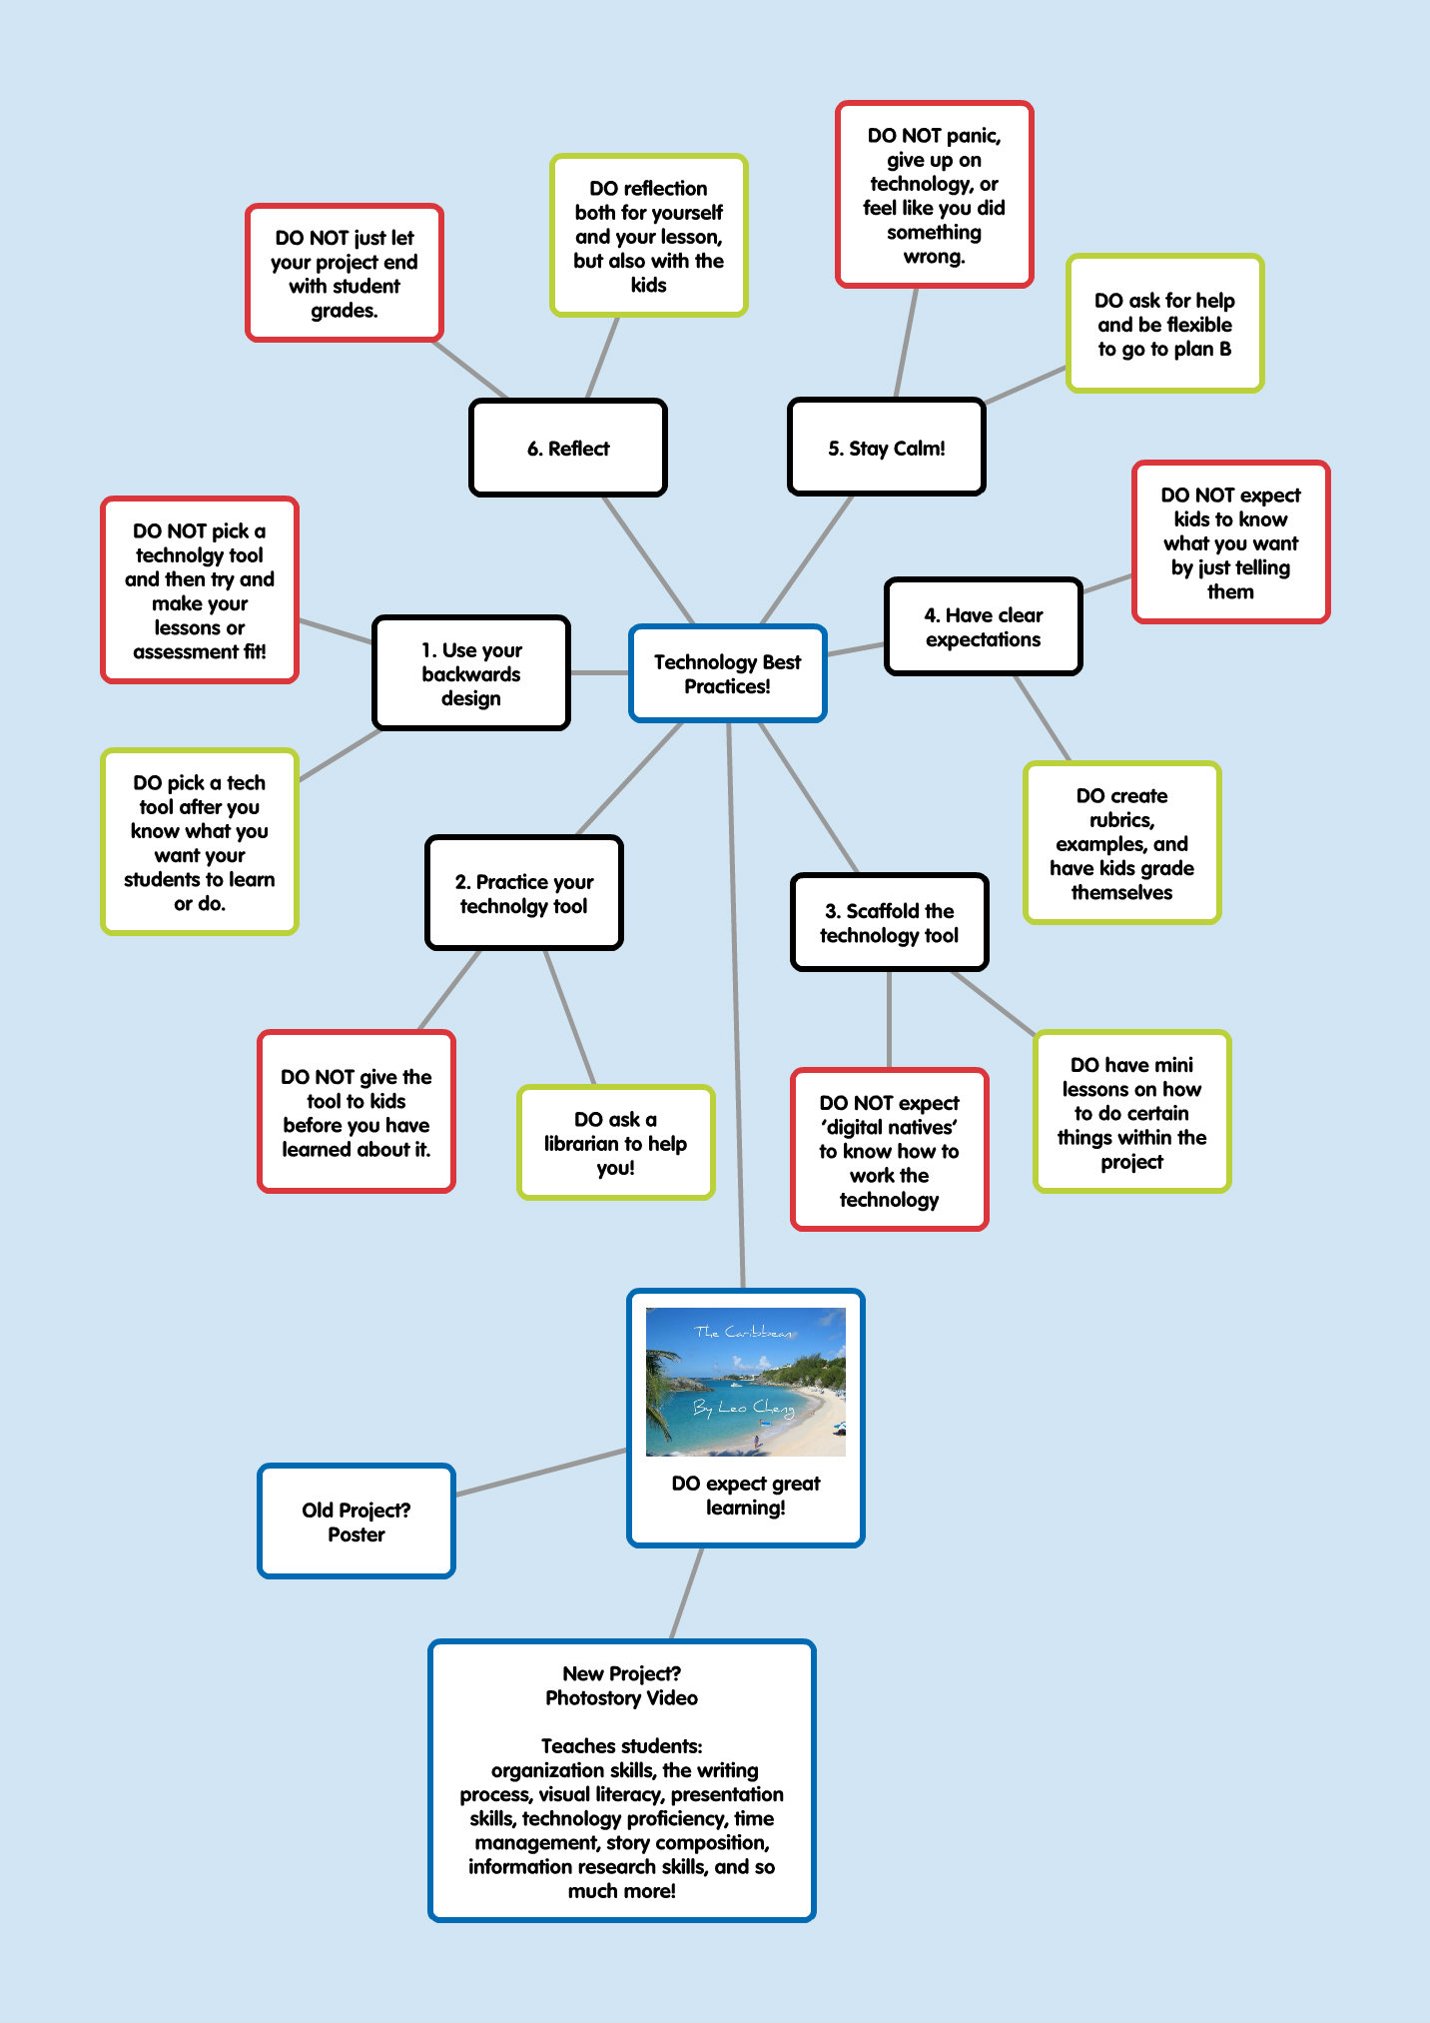

Technology Used in the Photostory Example:
Popplet: www.popplet.com
Dropbox: www.dropbox.com
Picnik: www.picnik.com (moving to Google+ soon)
Microsoft Photostory3: http://www.microsoft.com/download/en/details.aspx?id=11132

Where to go for resources: (bundled at http://fur.ly/8zjq)
My Website of Resources: https://sites.google.com/site/librariandigideas/
My Delicious Account: www.delicious.com/yeahsoup16
Internet for Classrooms: http://www.internet4classrooms.com/web2.htm
Tammy’s Favorite Web Tools: http://www.tammyworcester.com/TWHandouts/TW_Handouts/Entries/2010/6/27_Tammys_Favorite_FREE_Web_Tools_ISTE_2010.html
Super Teacher Tools: http://www.superteachertools.com/index.php#fun

